Install Ansible Automation Platform 2.2

Step 1: Download the Red Hat Ansible Automation Platform installer if your Red Hat Enterprise Linux environment is connected to the internet. Navigate to <https://access.redhat.com/downloads/content/480> and select the Product Variant & the

Version, as below:

System requirements:

Installing a Private Automation Hub instance requires the following:

|  |  |
| --- | --- |
| subscription | Valid Red Hat Ansible Automation Platform |
| **OS** | Red Hat Enterprise Linux 7.7 or later 64-bit (x86) or 8.2 or later 64-bit (x86) |
| Ansible | Version 2.9 required |
| RAM | 4Gb minimum |
| CPUs | 2 minimum |
| Disk | 20Gb dedicated hard disk space.Dependent on size of collections stored |
| Browser | A currently supported version of Mozilla FireFox or Google Chrome |
| Database | PostgreSQL version 10 |

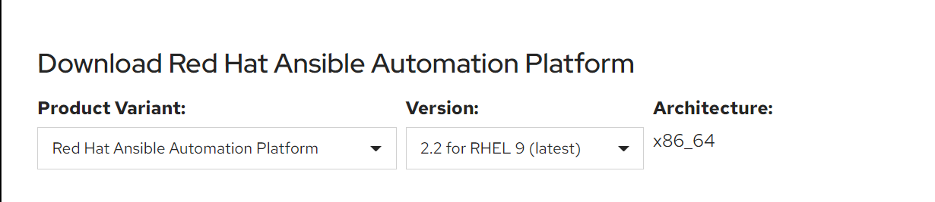

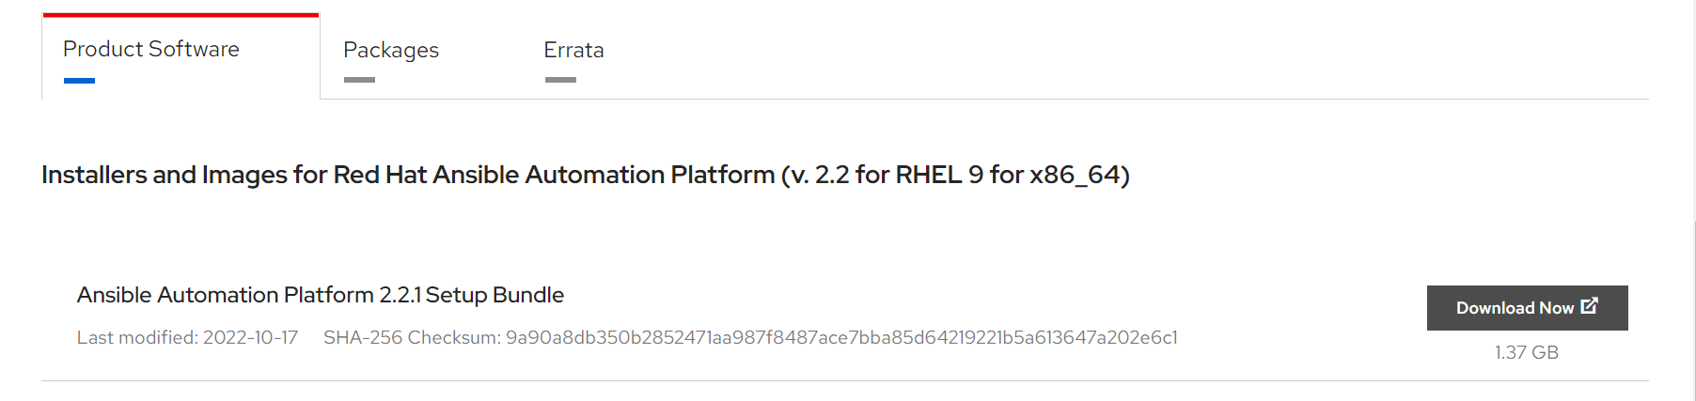

Step 2: Verify the necessary rpm repos are enabled.

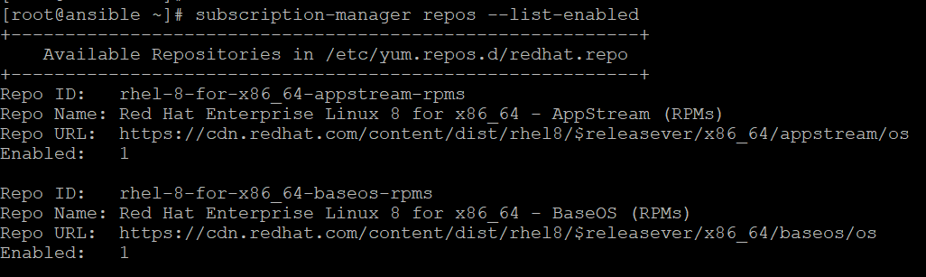

Step 3: Verify the hostname and IP Address of the Systems.



Step 4: Copy the file and Extract the files.

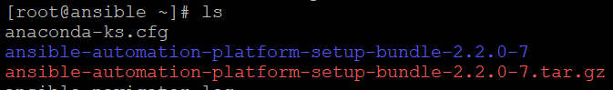

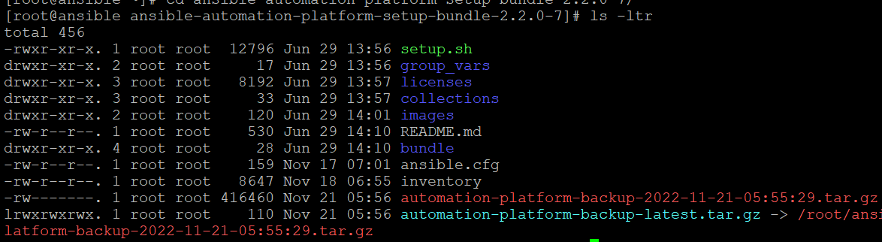

Step 5: Open the inventory file with a vim editor and edit inventory file parameters to specify my installation scenario.

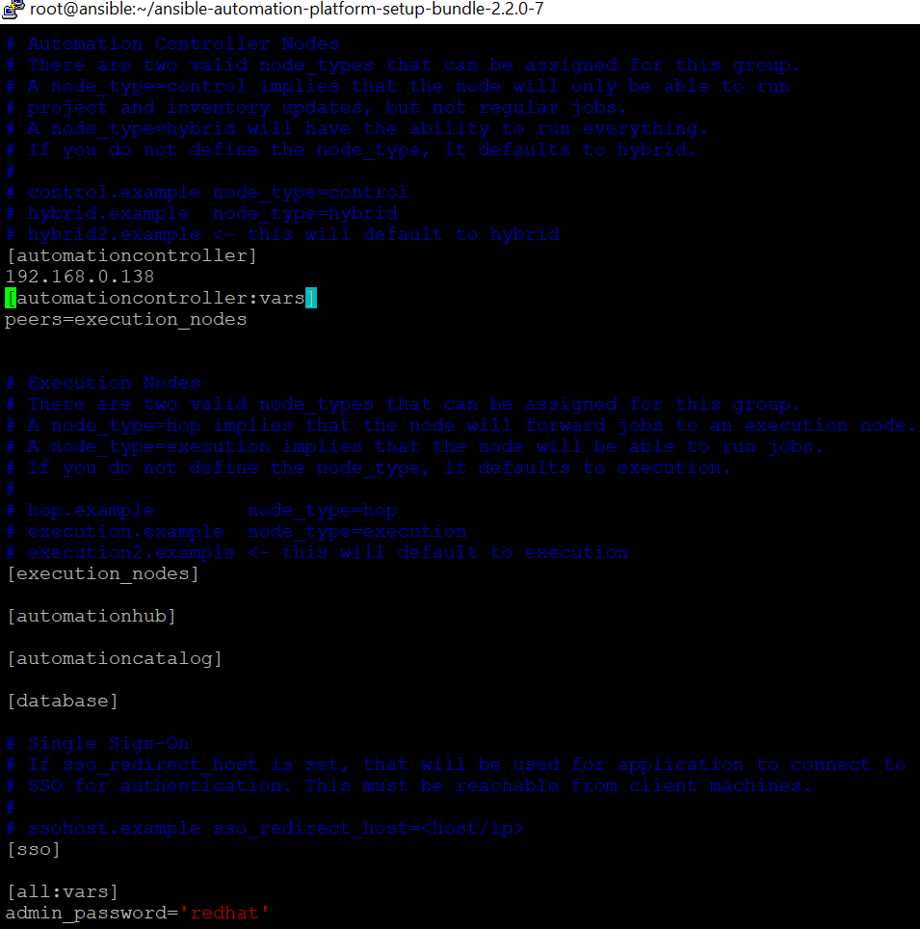

Step 6: To run the Red Hat Ansible Automation Platform installer setup script.



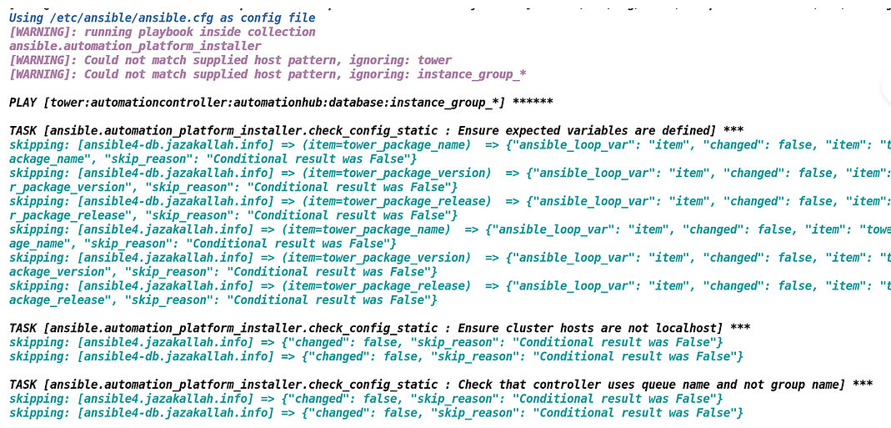

Step 7: To verify the Ansible Automation Hub services status installation completed. 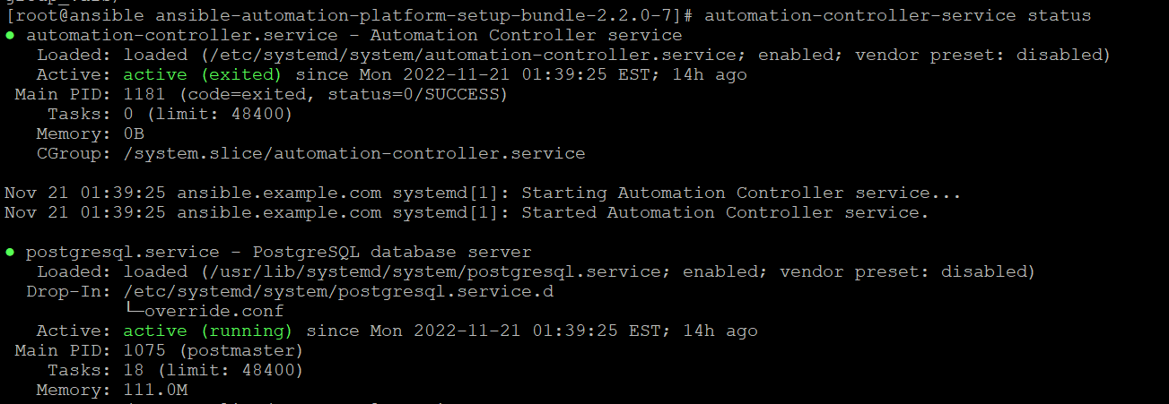

Step 8: To verify the Ansible Automation Hub User Interface at <https://192.168.0.138/#/login>

